Report – Model Building
Angel Thu Do
November 2025

Executive Summary
This document describes the model built to predict the binary response variable “target” influenced by account quality, seasonal effect, and macroeconomics effects over time.
In order to choose the best model with the most accuracy, five different models are built and trained: Logistic Regression, Random Forest, Histogram-based Gradient Boosting (HistGradientBoosting), LightGBM, and XGBoost.
In this report, XGBoost is the best model, which achieves the highest validation AUC (0.7148).

Modeling Approach
1. Problem Type
- Binary classification: Predict the binary response variable target.
2. Data Handling
- Data Merge: 6 CSV files merged into a single dataset.
- Temporal Split:
  - Build set (Date_ym < 2022-05) → train (80%) / validation (20%)
  - Hold-out set (Date_ym >= 2022-05) → test set → final evaluation
- Segmented evaluation: Performance analyzed per segment S and over time (Date_ym).
3. Feature Engineering
- Predictor features: P1–P19 (account/macro variables)
- Temporal features: year, month, quarter, day_of_year
- Seasonal features: is_jan, is_feb, is_jan_feb
- Cyclical encoding: month_sin, month_cos to capture seasonal cycles
- Time trend: months_since_start to capture temporal evolution
4. Modeling Pipeline
- Preprocessing: Scale features if needed (Logistic Regression uses StandardScaler).
- Model Training: Five models trained independently:
  - Logistic Regression
  - Random Forest
  - HistGradientBoosting
  - LightGBM
  - XGBoost
- Validation: Early stopping for boosting models to prevent overfitting.
- Metrics Computed:
  - AUC (Train, Validation, Holdout)
  - Accuracy (Train, Validation, Holdout)
- Best Model Selection: Based on highest validation AUC.
5. Evaluation Approach
- Hold-out set evaluation: Measure performance on unseen data.
- Temporal evaluation: Track AUC and Accuracy over months.
- Segment × Time evaluation: Check model stability across customer segments and time.
- Visualization: Plots for comparison (bar plots, heatmaps, ROC, precision-recall, dashboard).

Charts
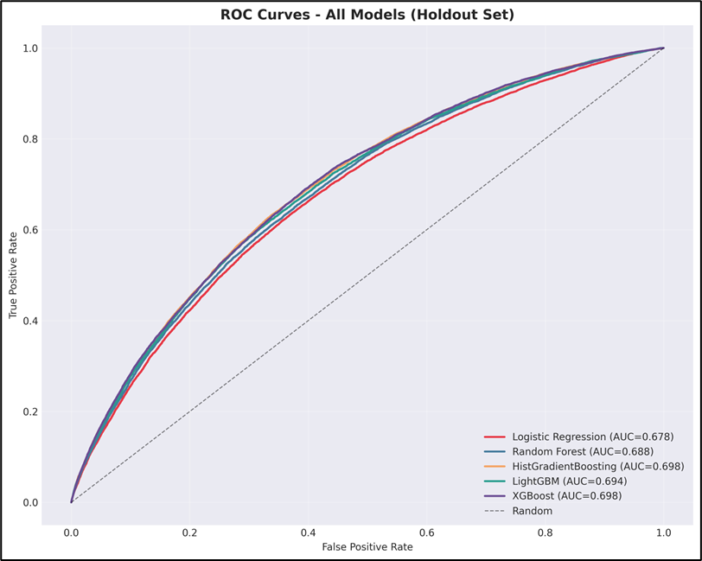

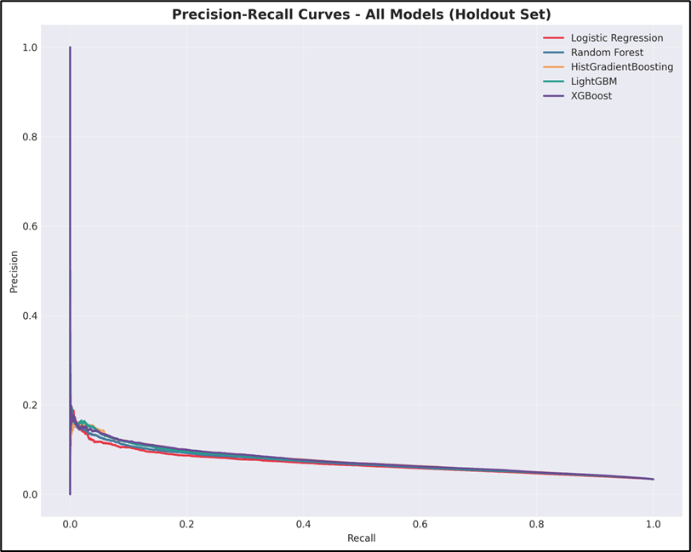

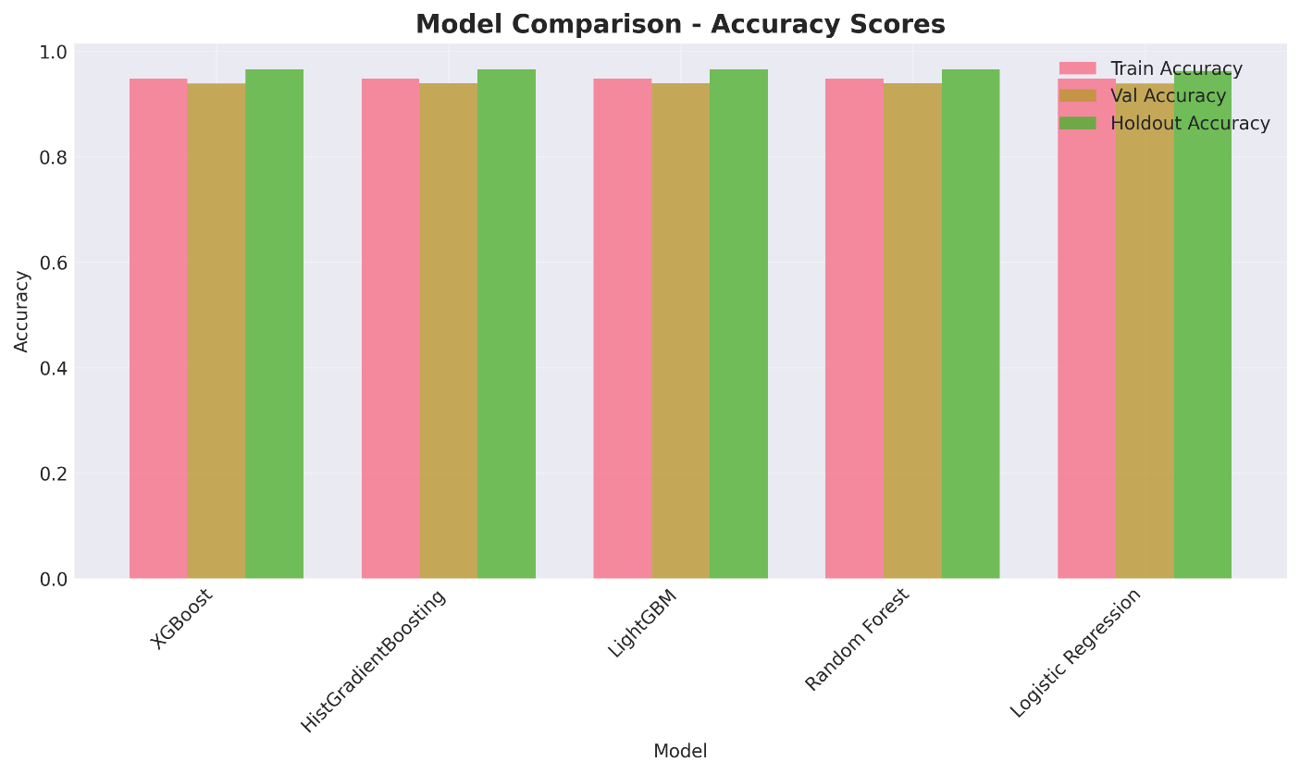
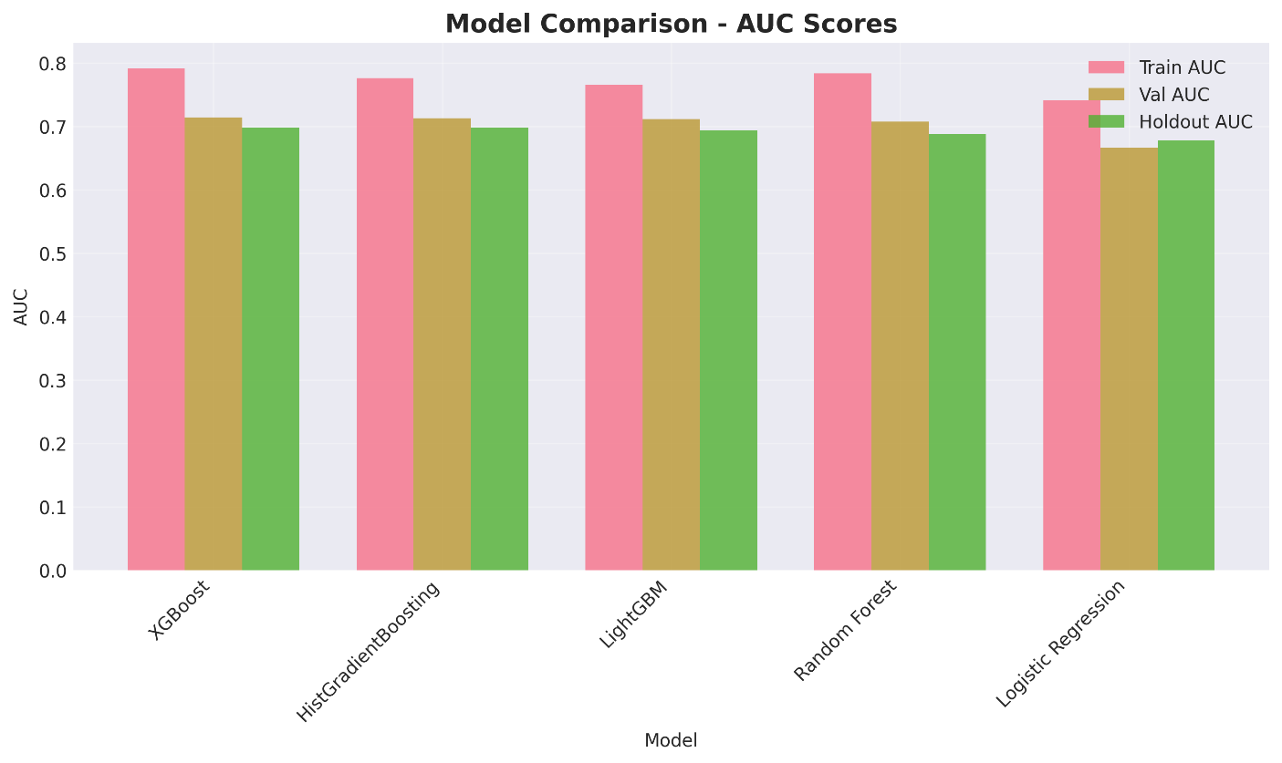

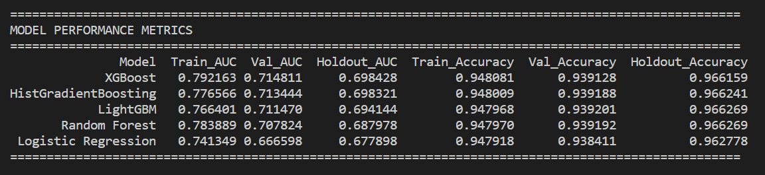
- For model comparison, there is not much different between models.
- Since the data is imbalance, validation AUC is preferred to evaluate model performance.
- Following charts and table, XGBoost achieves the highest validation AUC (0.7148) compared to other models.
- Thus, XGBoost is shown as the best model in this report.

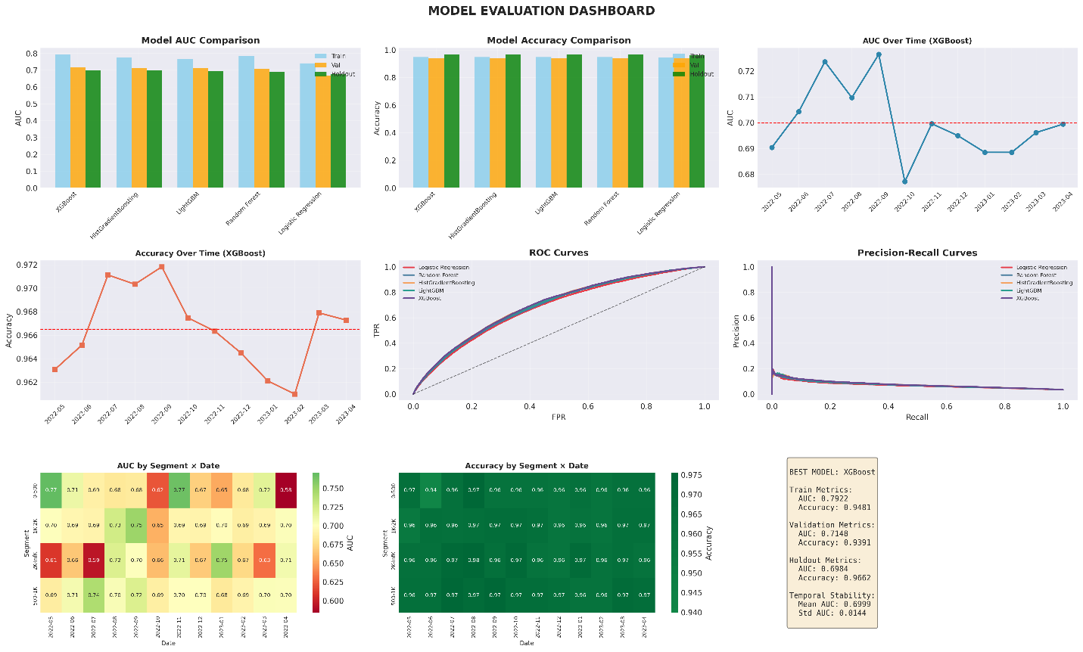
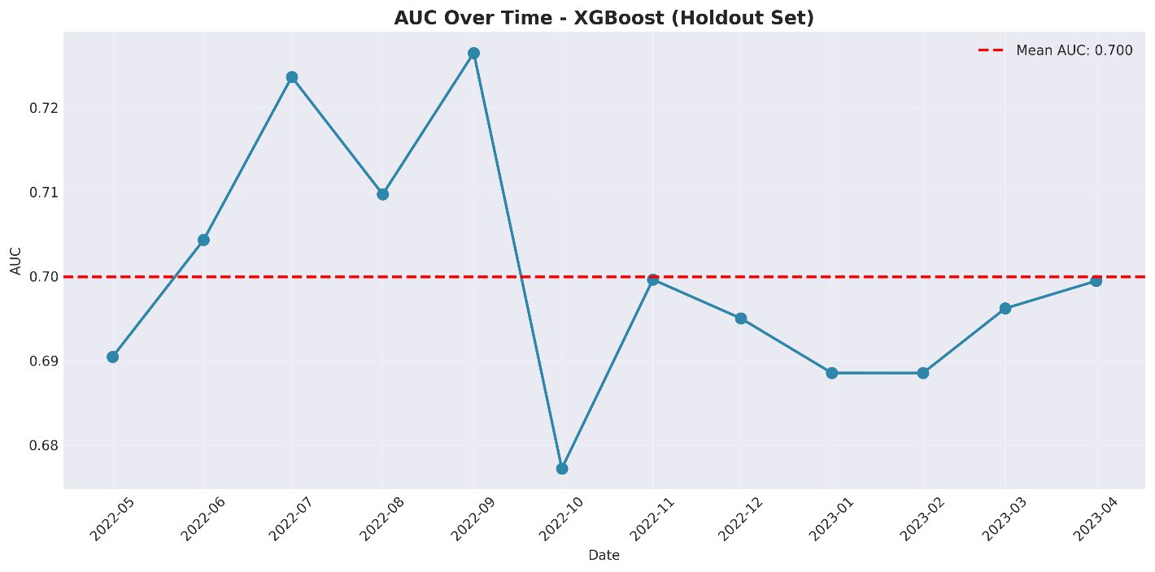
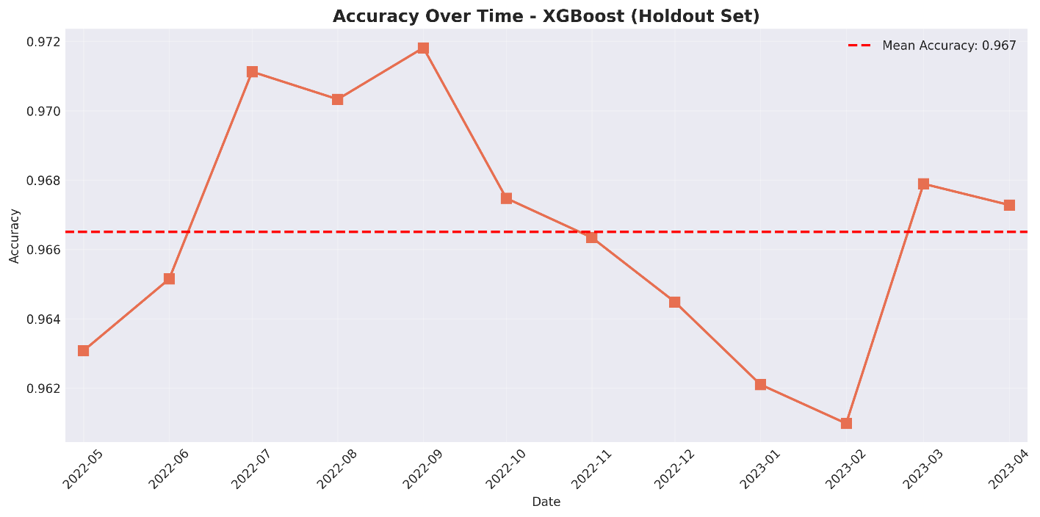

- In evaluation, following the best model XGBoost, the highest AUC (by Segment x Date_ym) is 0.77 with 0-500 in November 2022, while the lowest AUC (by Segment x Date_ym) is 0.58 with 0-500 in April 2023.
- Due to the imbalance dataset, accuracy metrics is overfitting (by Segment x Date_ym).

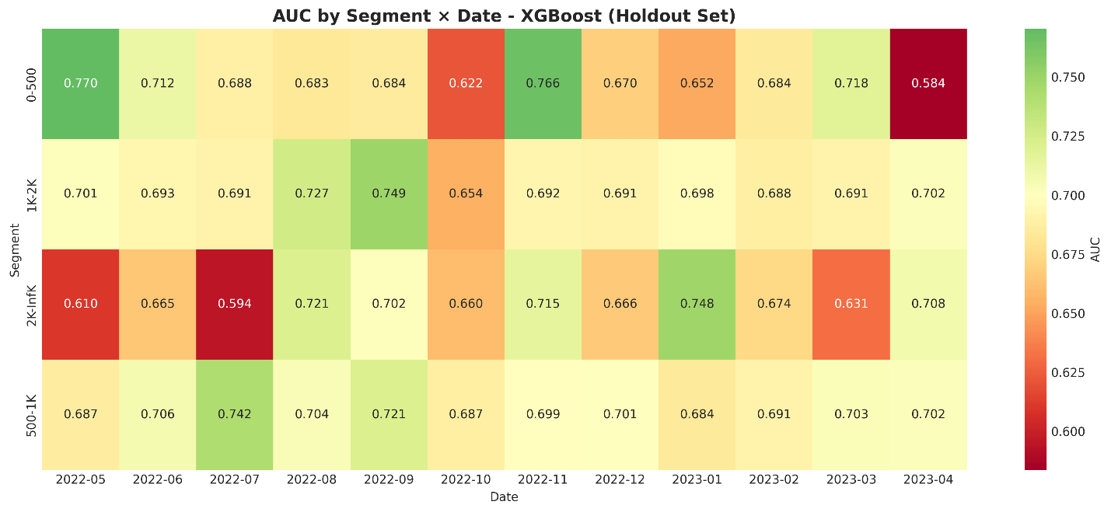

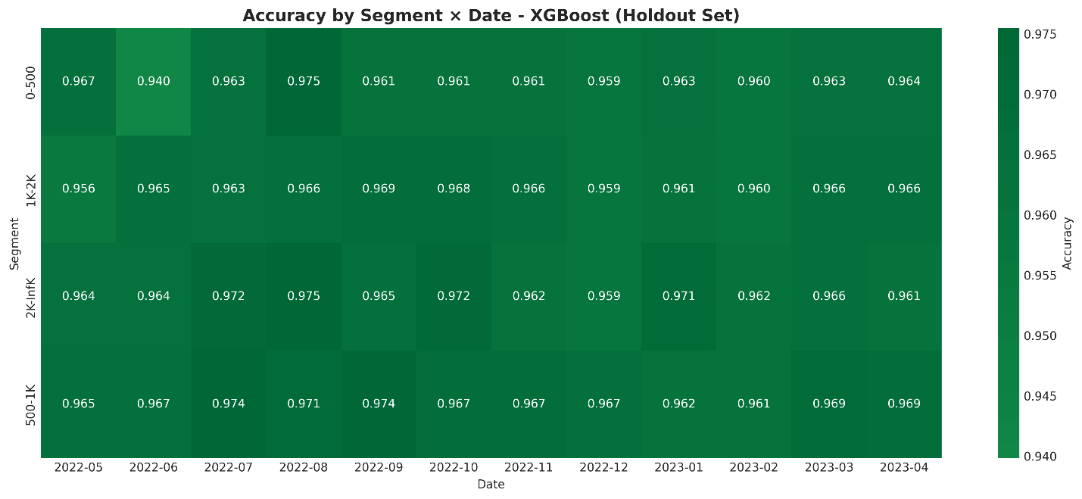

- In evaluation, following the best model XGBoost, the highest AUC (by Segment x Date_ym) is 0.77 with 0-500 in November 2022, while the lowest AUC (by Segment x Date_ym) is 0.58 with 0-500 in April 2023.
- Due to the imbalance dataset, accuracy metrics is overfitting (by Segment x Date_ym).
Conclusion
This approach is a multi-model, time-aware binary classification pipeline. It combines:
- Gradient boosting models for high predictive performance
- Linear model baseline for interpretability
- Temporal and segment evaluation for stability and reliability
It’s a structured pipeline: data loading and merging → feature engineering → train/validation/test split → model definitions (5 models: LG, RF, HGB, LGBM, XGB) → model training → best model selection → hold-out set evaluation → metrics table → temporal evaluation (by Date_ym) → Segment x Date_ym evaluation → visualization (individual plots) & dashboard → final summary.

Supplementary
PPT slides is enclosed with this report.
To run the code, please download the “test” zip folder including: model.py, requirement.txt.
All results are saved in the “results” folder.
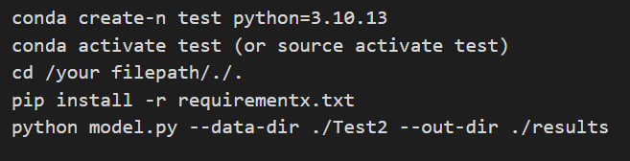
Following command to create conda environment, install packages, and run python file.

Below is the folder structure.
